**Git assignments**

**1 assignment**

1.git version

Git config –global user.name “user name”

Git config –global user.email “email”

Git config –global – list

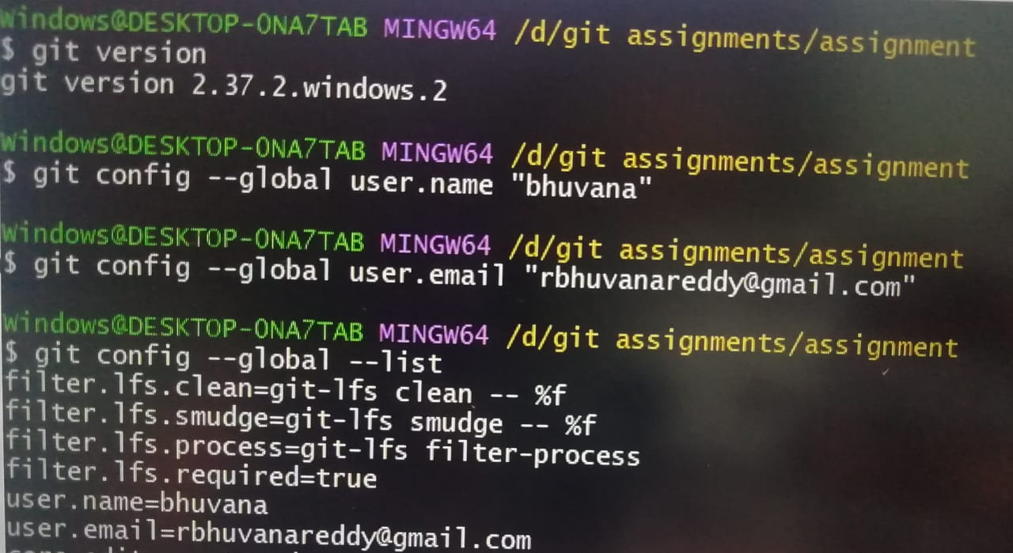

Notepad++

Notepad++.exe bash –profile

Git config –global –e

Git init GitDemo

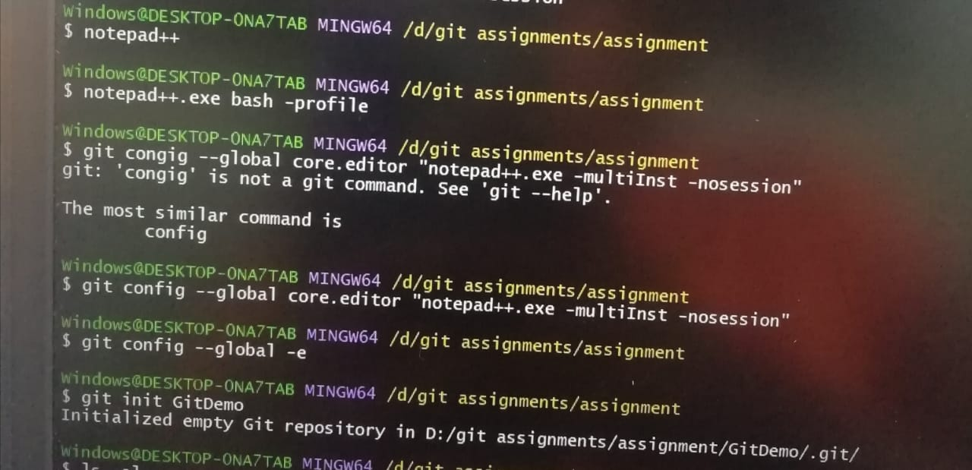

Ls –al

Cat welcome.text

Git status

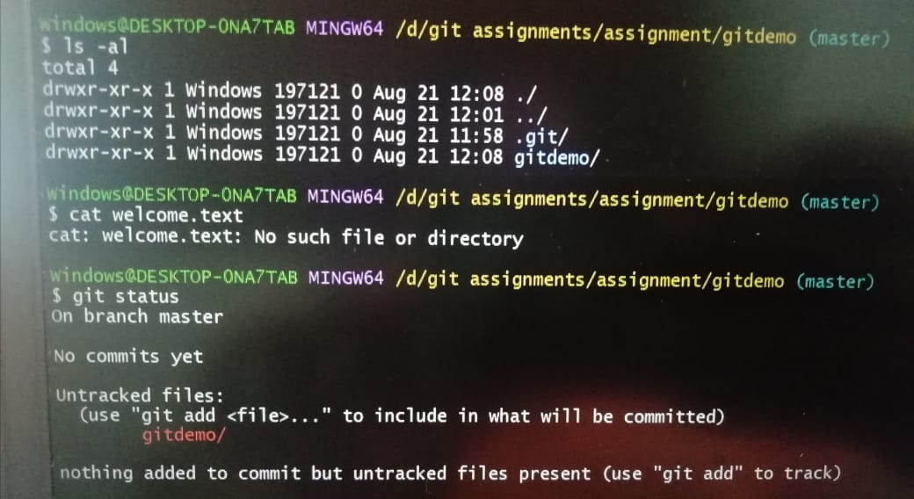

**2 assignment**

1. touch .gitignore => cat .gitignore => git add . => git status

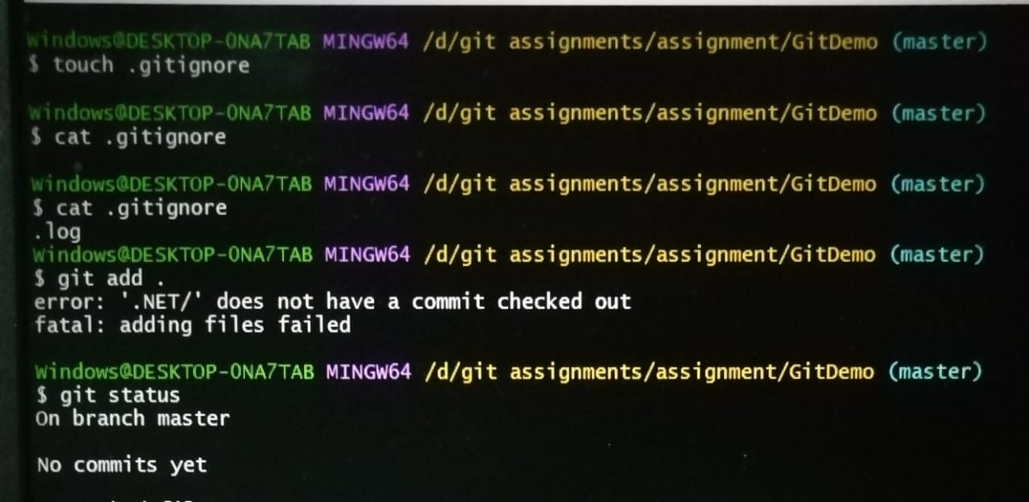

1. git add . => it won’t add .log files but add .txt files

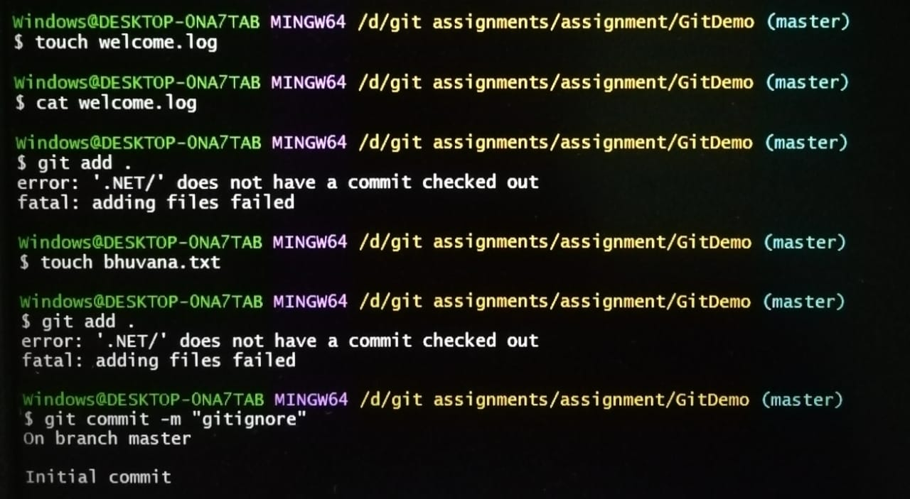

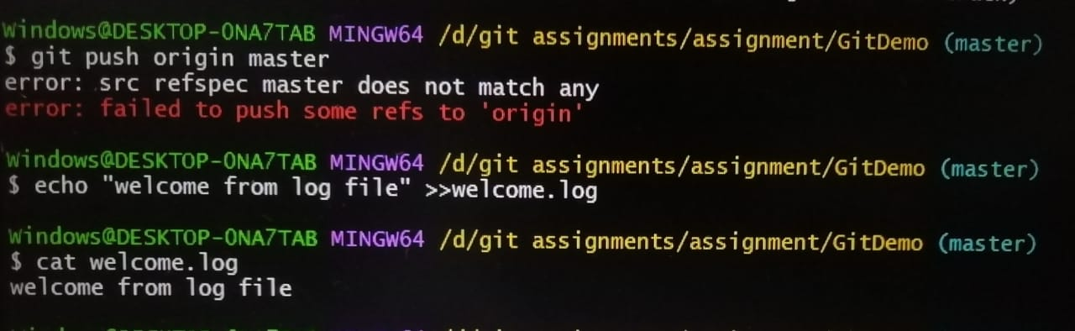

**3 assignment**

git branch gitNewBranch.

git branch .

git checkout gitNewBranch.

touch gitnew.txt = > git add . => git commit –m “commit from new branch”.

git status.

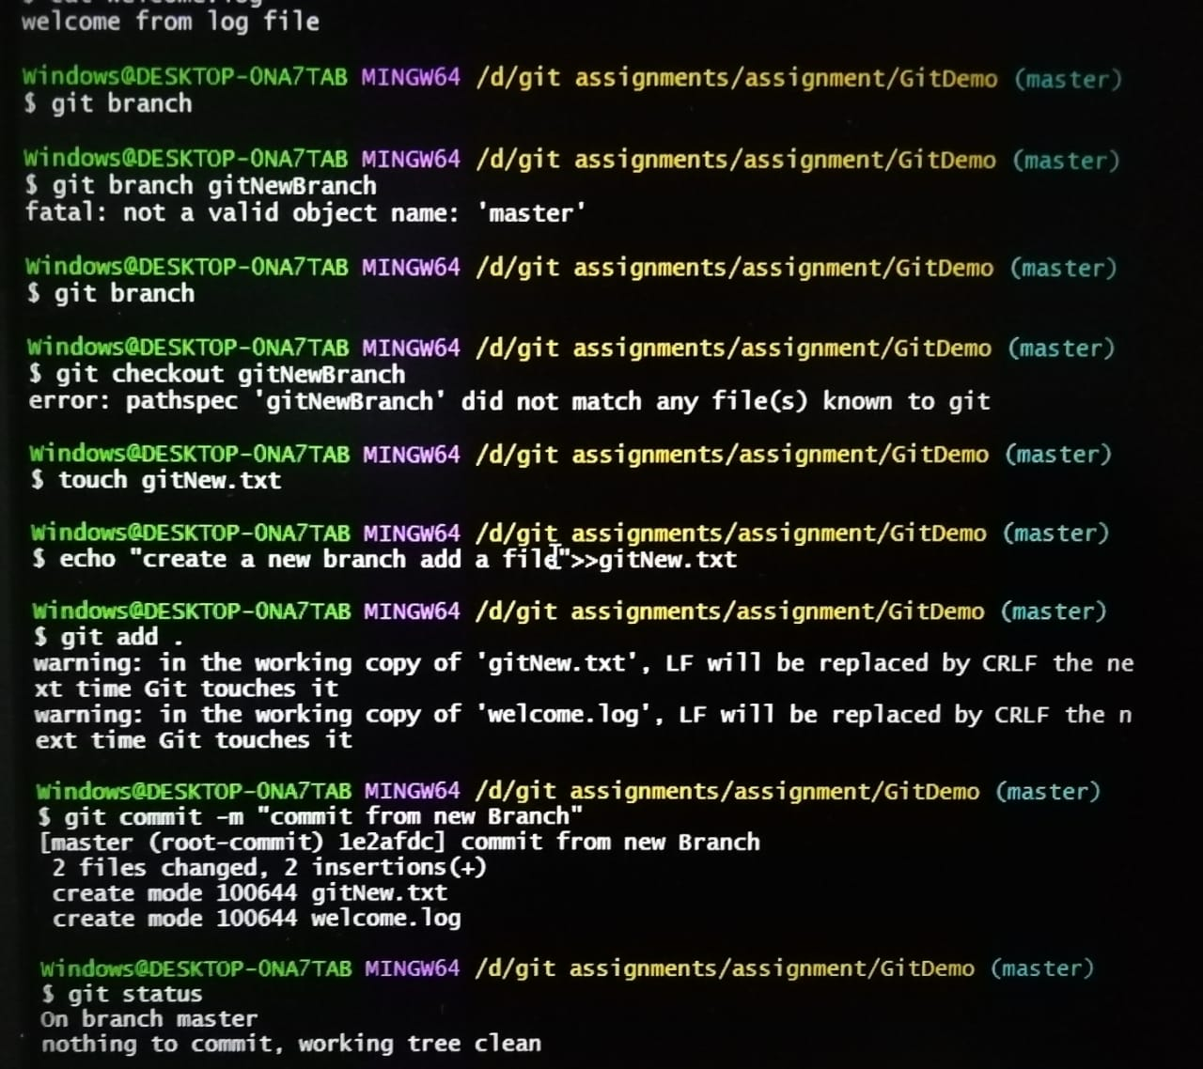

Merge

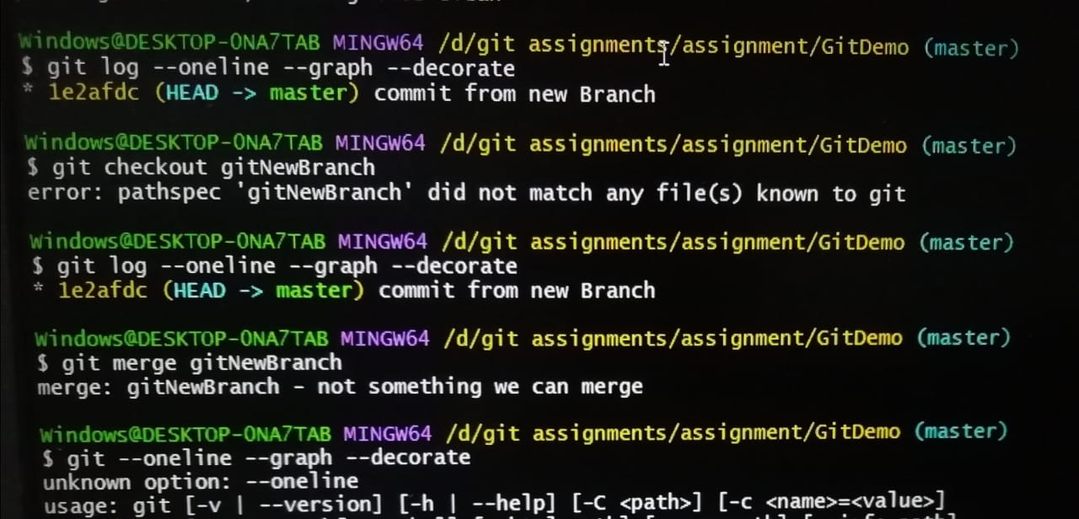

Delete

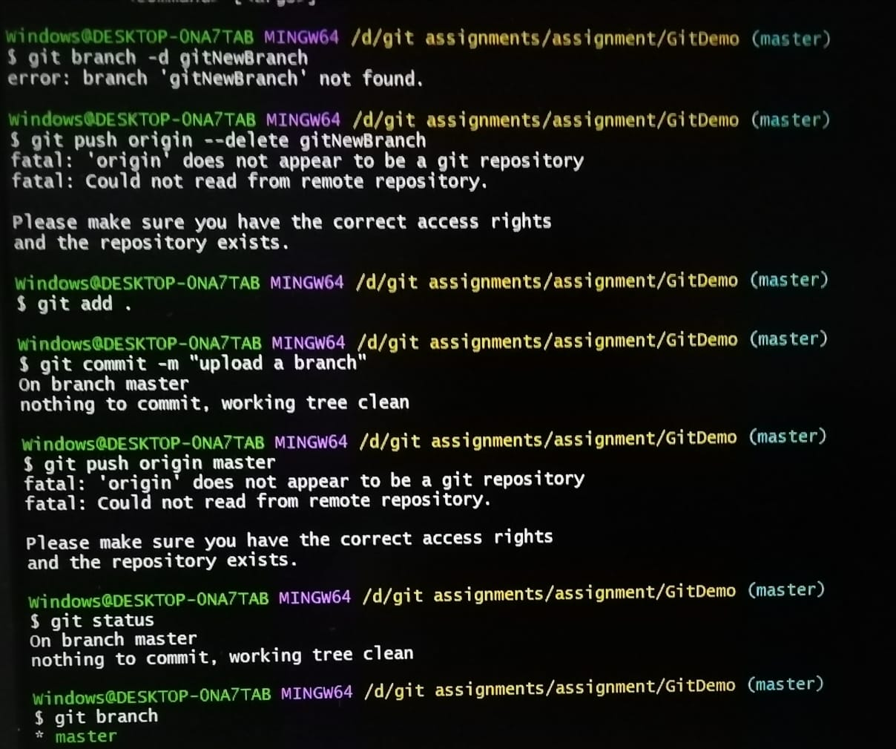

4 assignment

1. git status
2. git branch gitWork
3. touch hello.xml
4. git commit

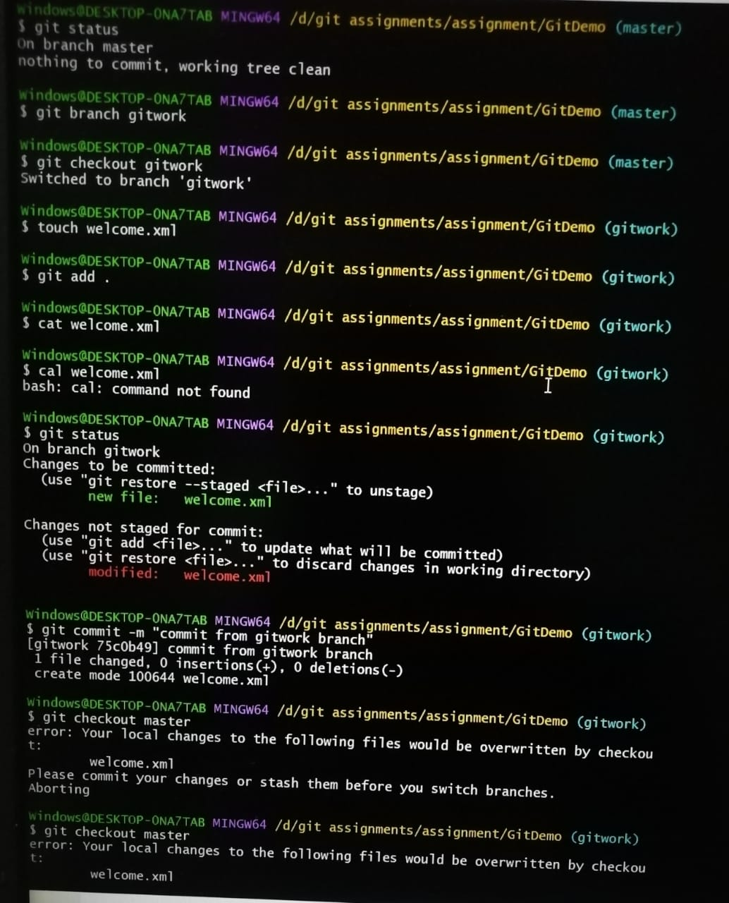

git log –oneline –graph –decorate –all

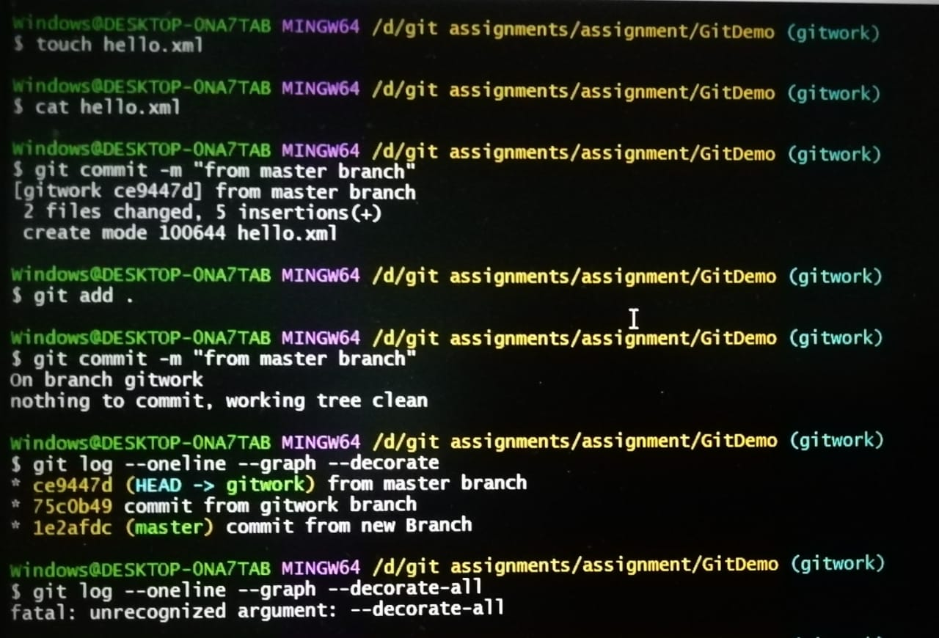

5 assignment

